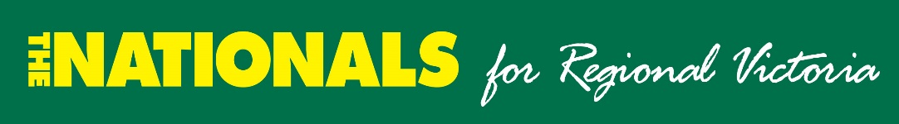

Murray Plains AEDC

invites members and friends to the Annual General Meeting.

On Sunday 31st October

At the

Gunbower Hotel
18-20 Murray Valley Hwy Gunbower

Meeting start: 11.00am

Followed by lunch and drinks at bar prices

Guest Speakers will be

The Leader of the Victorian Nationals;
Peter Walsh

and Brad McEwan; Ambassador for Beyond Blue.

RSVP acceptances by Wednesday 27th October.

Rob Amos, Secretary - 0413 040199 or ra@armadalehouse.com.au
Elaine Lees, President - 0417 143 686 or glenelso@bigpond.com

Damian Kelly, Treasurer - 0438 163 218 or karendamian@bigpond.com

